Auto Scalling

Aws auto scaling monitors your application and automatically adjusts capacity to maintain steady, predictable performance

Step 1 : - Select ami id and copy it

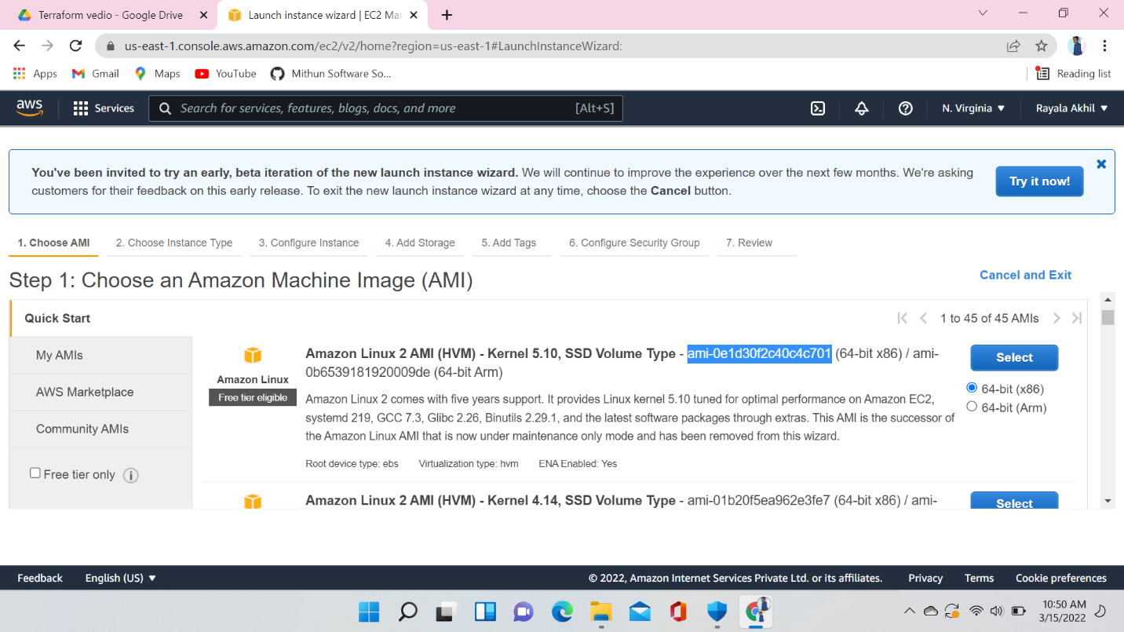



Here I don’t have any running instance

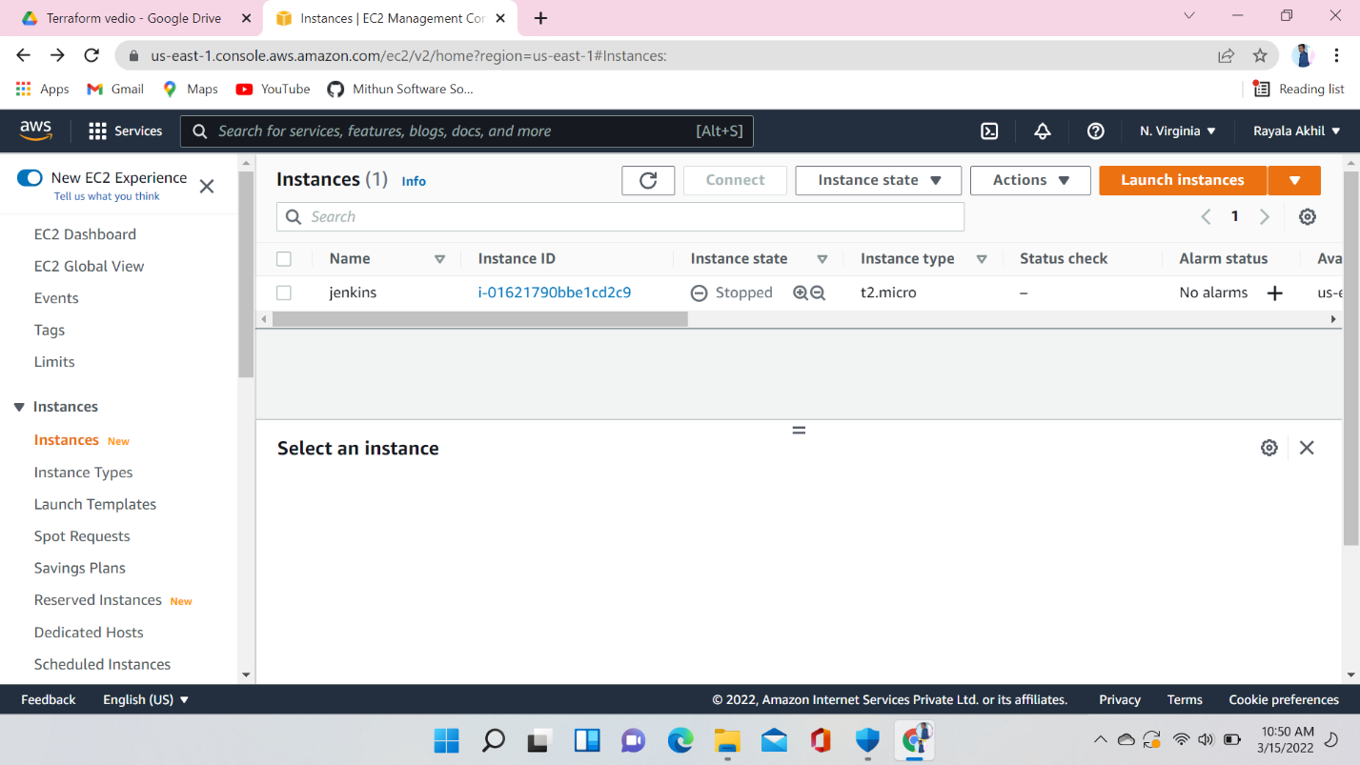

Step 2 :- create launch configuration here I am showing how to create launch configuration



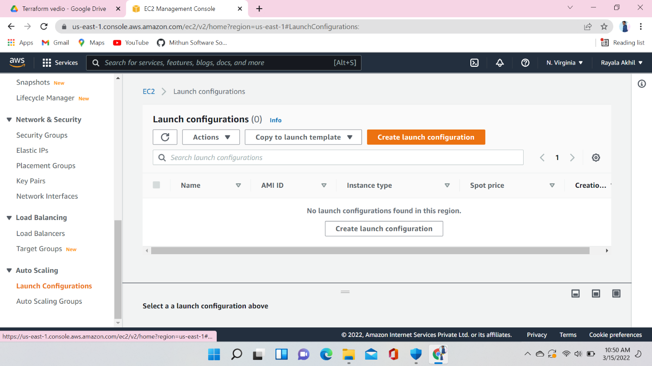



Create launch configuration and in Amazon machine image paste the ami Id which you have copied in the first step and paste here and select instance type here I am selecting t2.micro



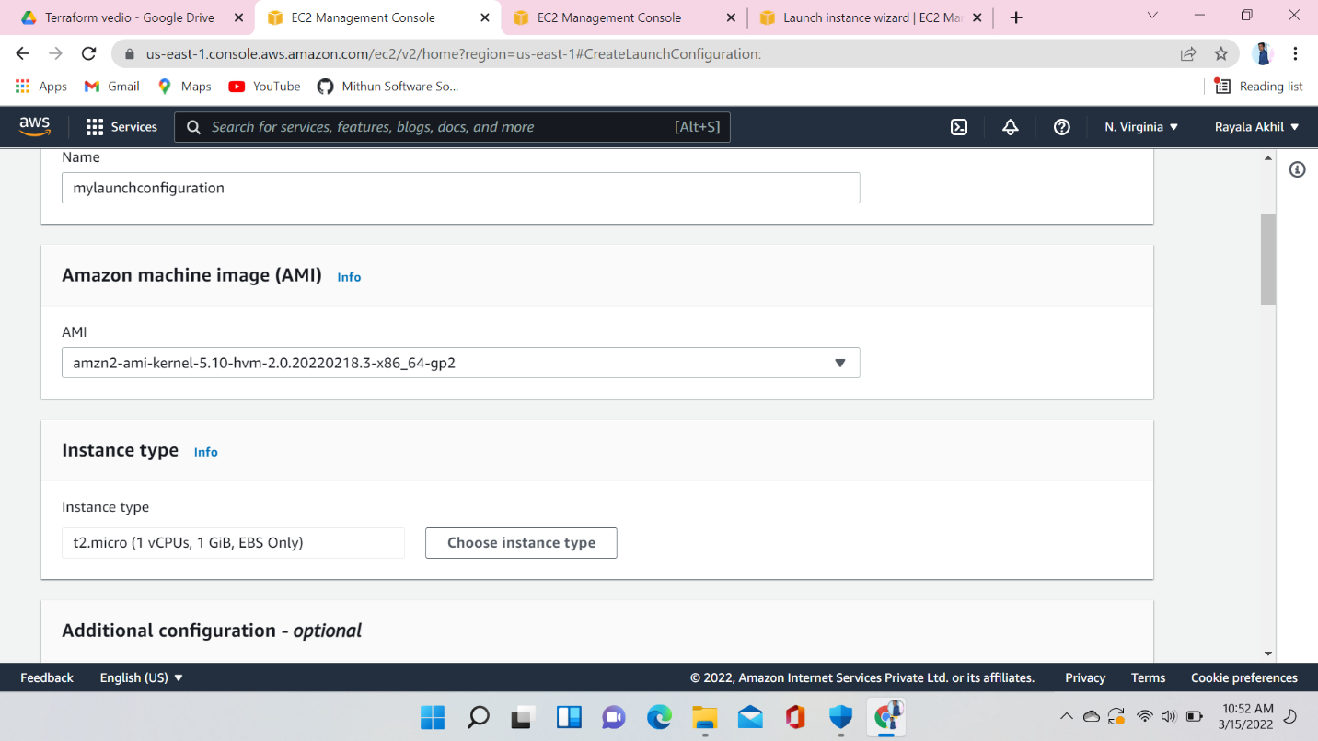

Auto Scaling Security Group provide security Rules

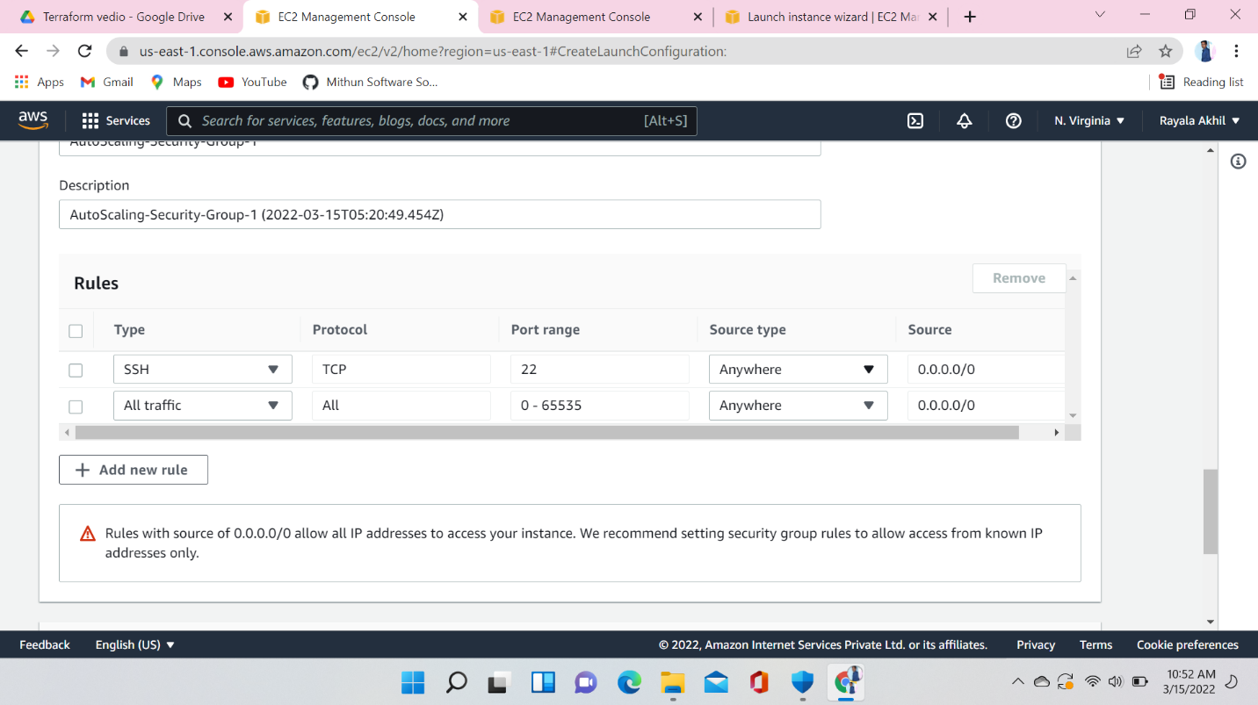

Key Pair create new keypair or choose an existing one

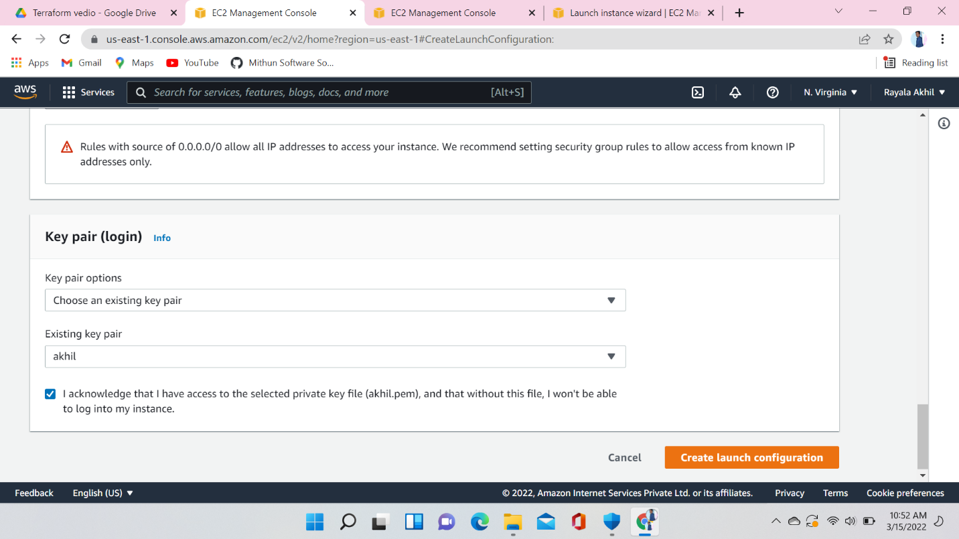

Here launch configuration was successfully created after this create auto scaling group

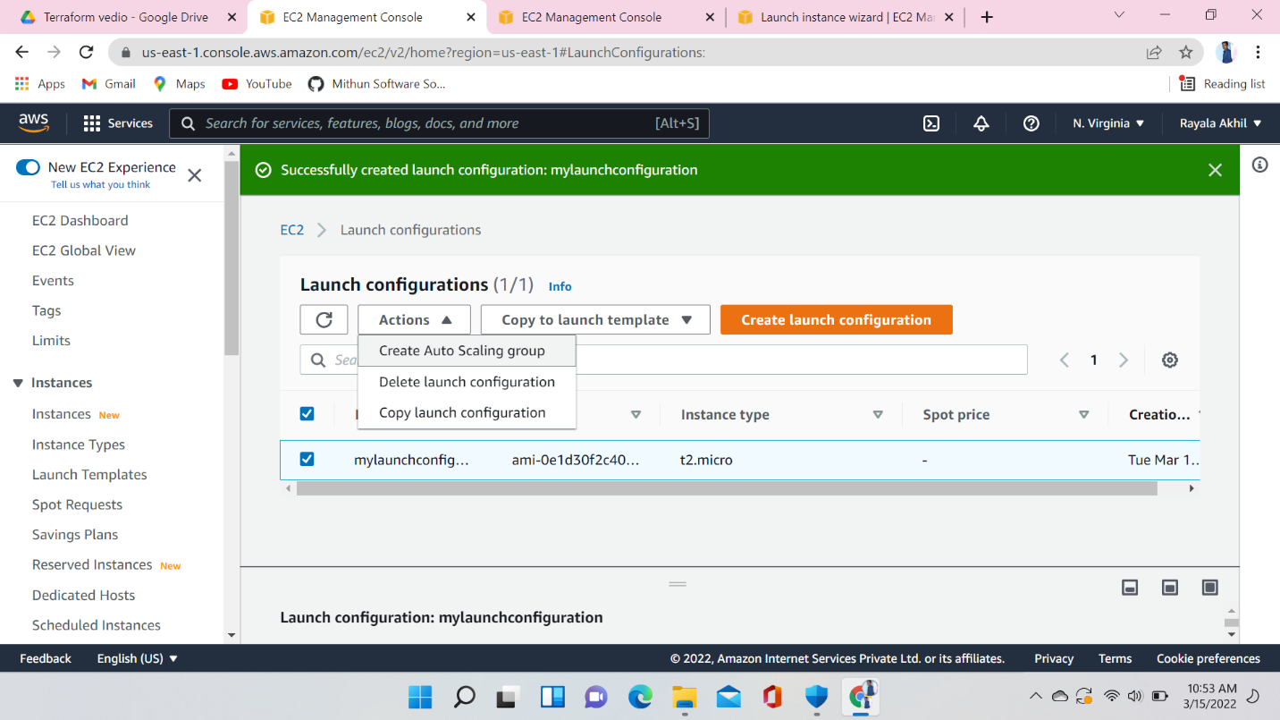

Creating auto scaling group using launch configuration

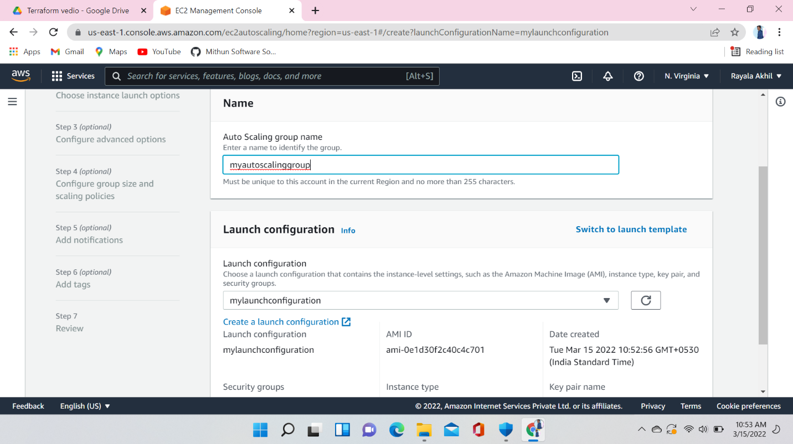

Choose the VPC that defines the virtual network for your auto scaling group

Define which availability Zones and subnets your auto scaling group can use the chosen VPC

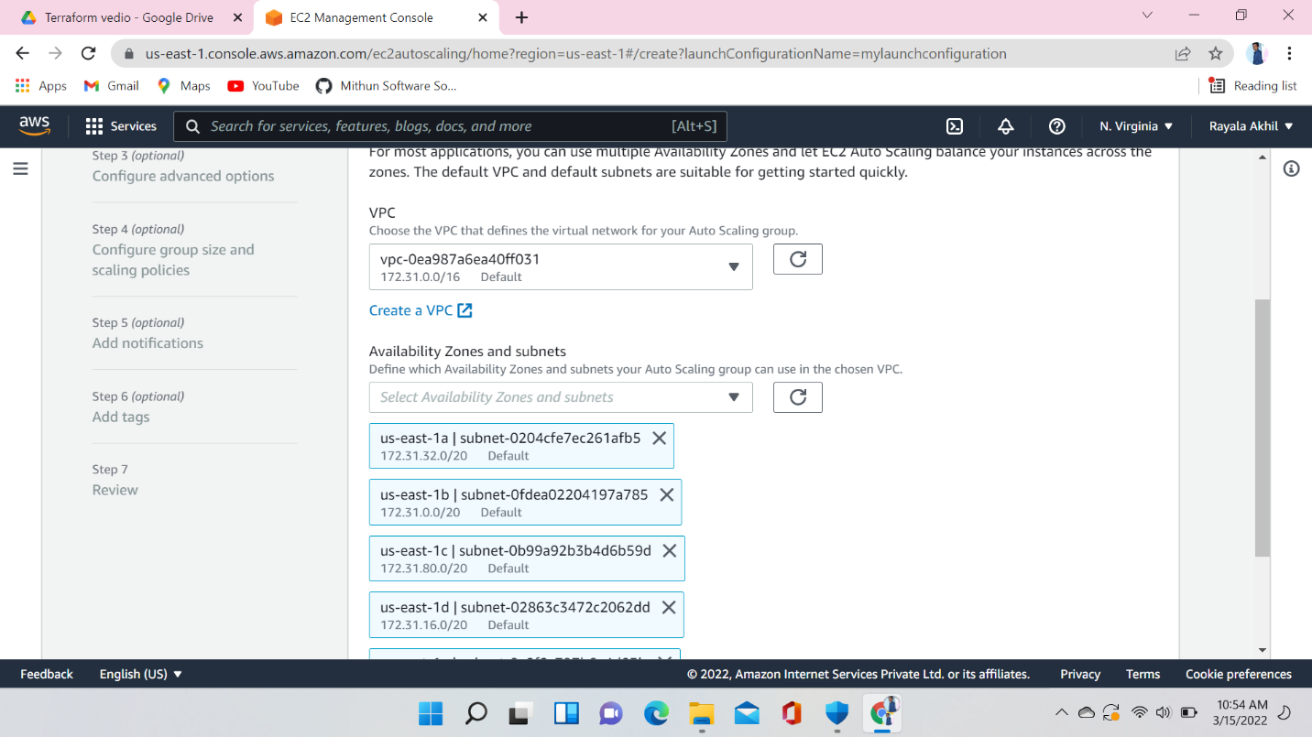

Here I am giving desired capacity 2, minimum capacity 1, and maximum capacity 2,

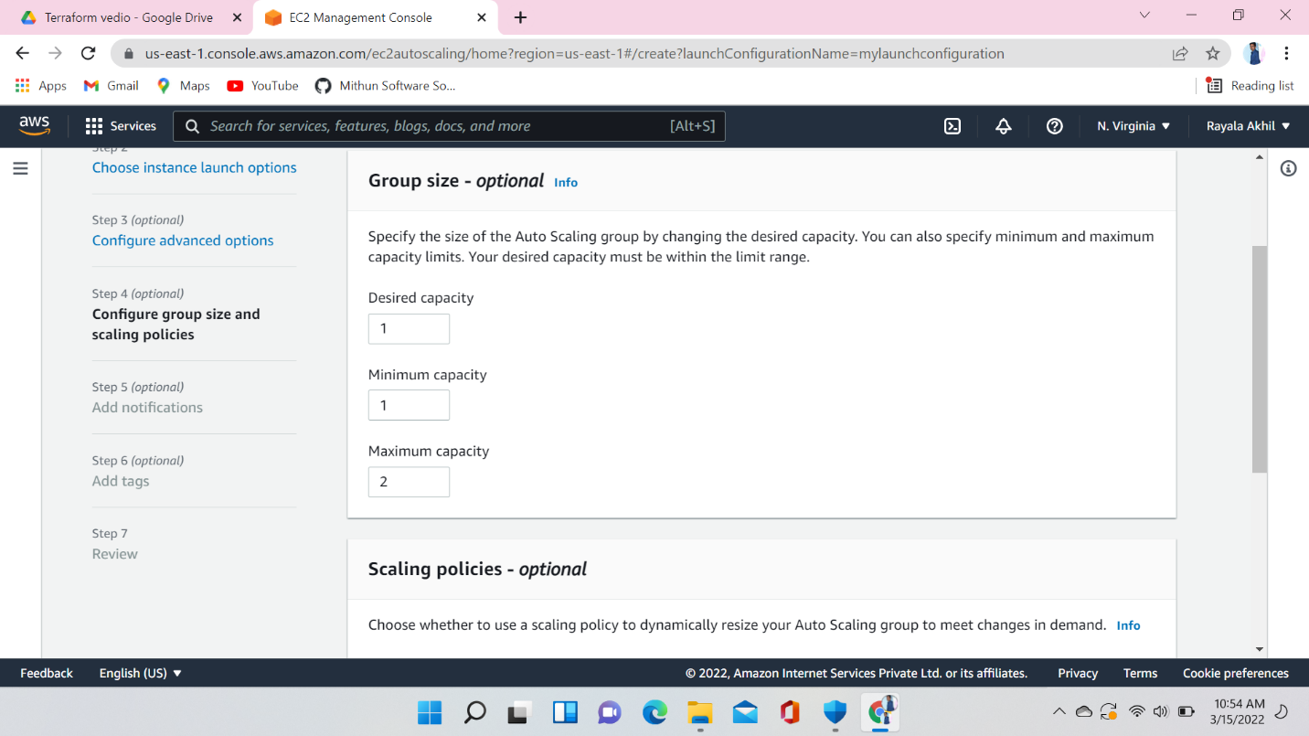

Here I am giving metric type (Average CPU utilization) target value 50 :- it means when CPU utilization will be more than 50 it will create one more instance

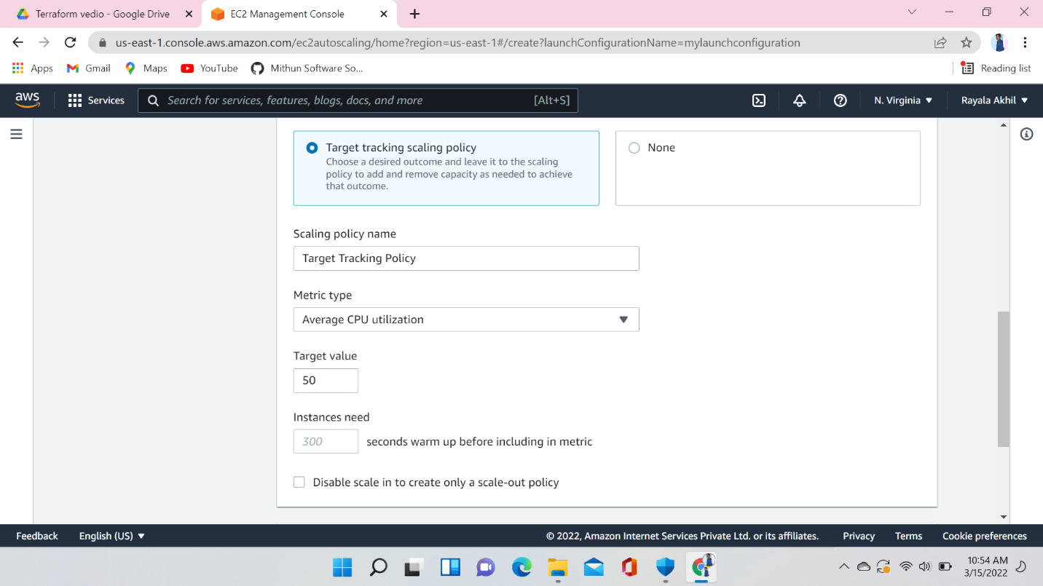

Autoscaling group created successfully

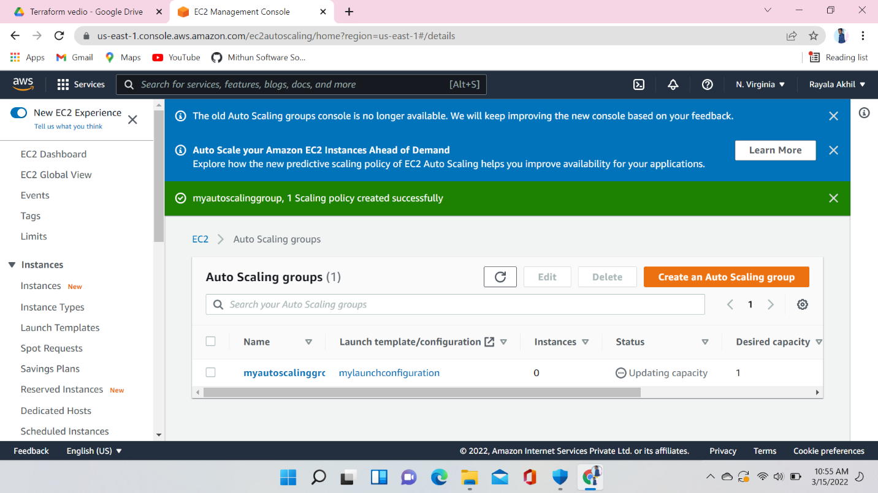

One instance have been created automatically connect this instance to the terminal and install stress

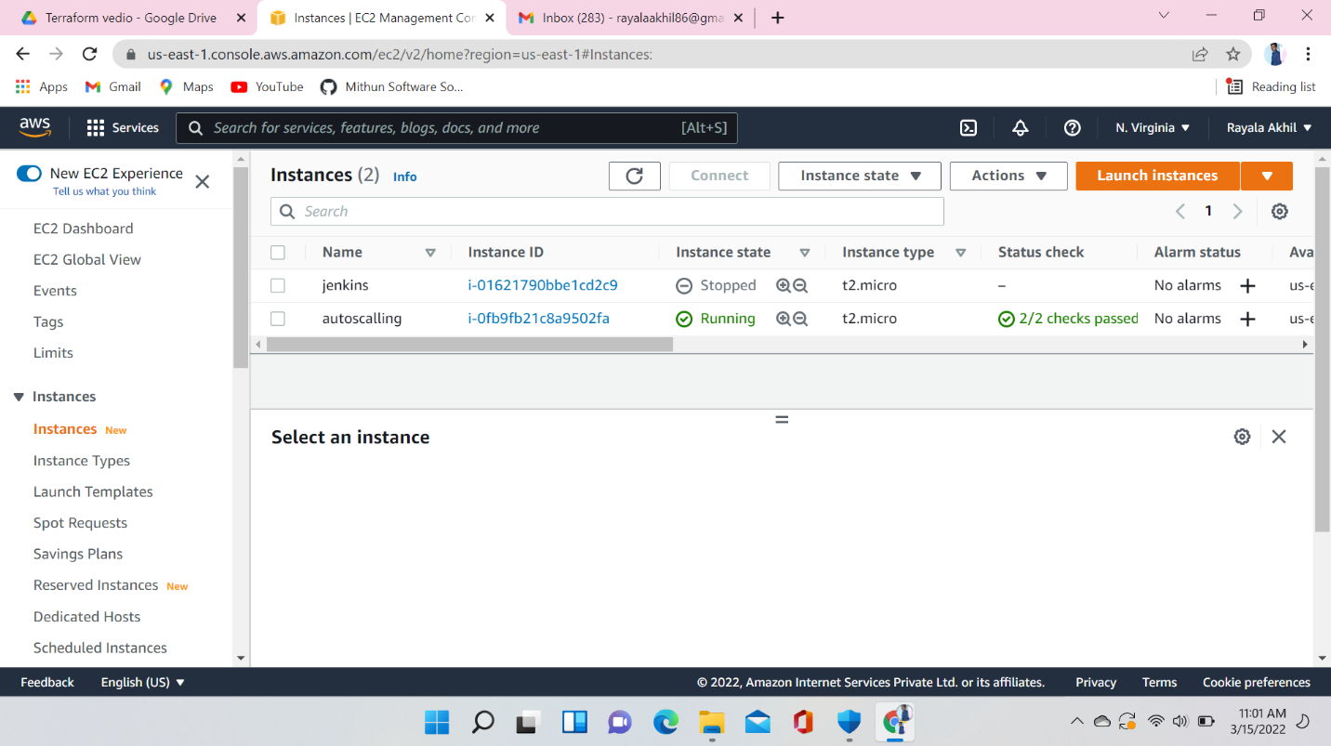

Using this command install stress

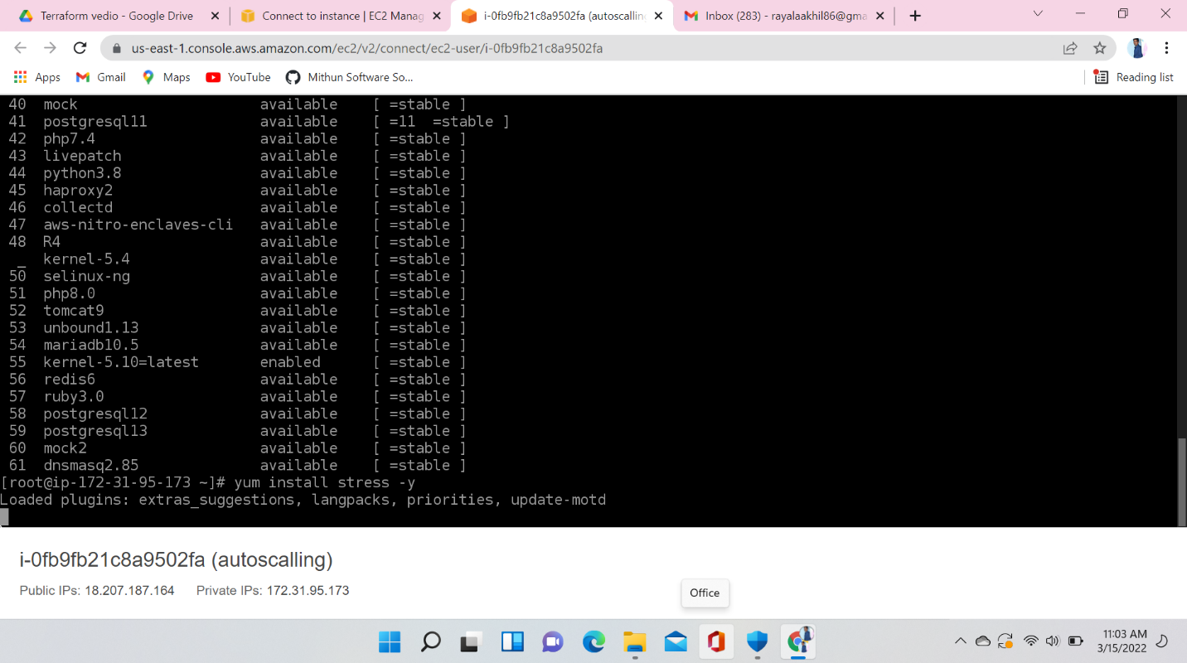

Use the top command and check the CPU utilization , here the CPU utilization is 0.0 so I will increase the CPU utilization using stress

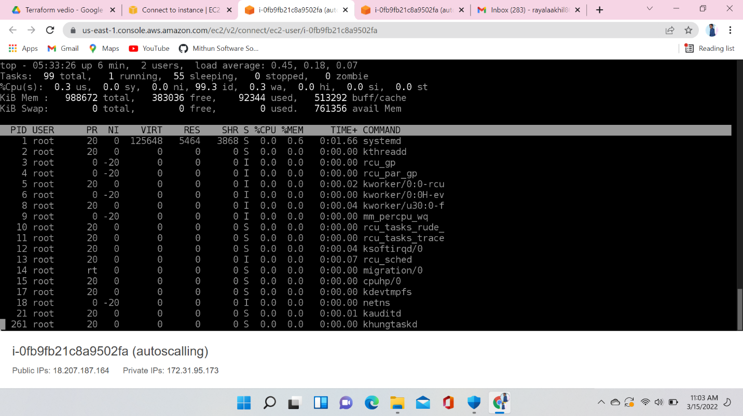

Here I am increasing the CPU utilization

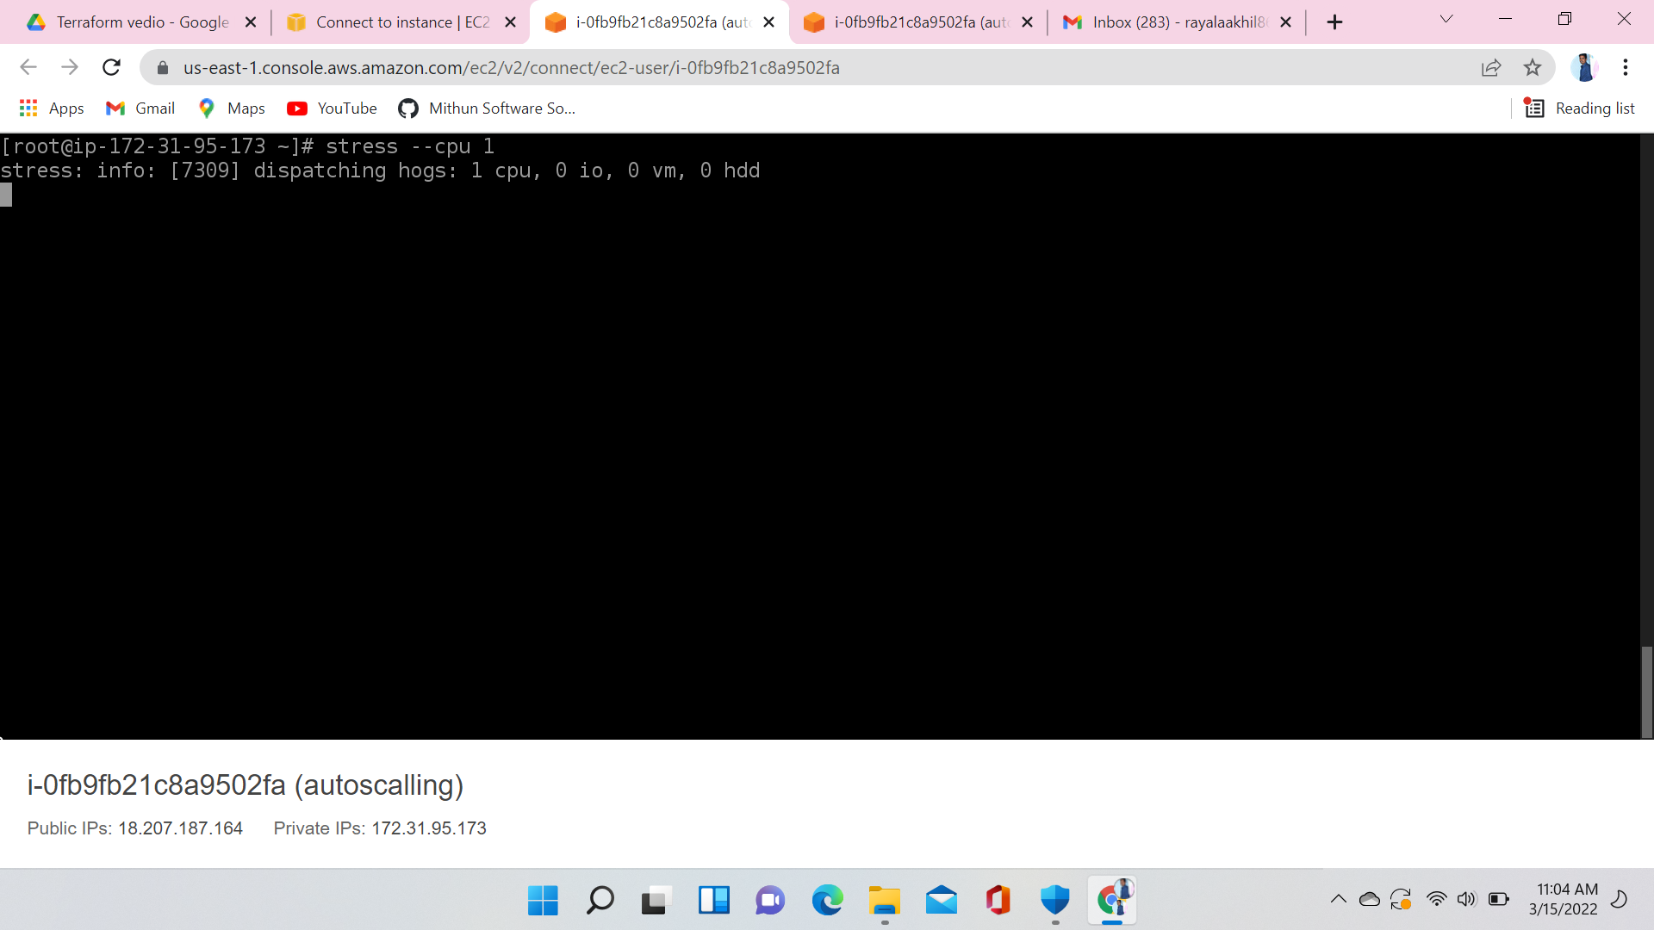

After applying stress on CPU (check the below picture how much it was increased)

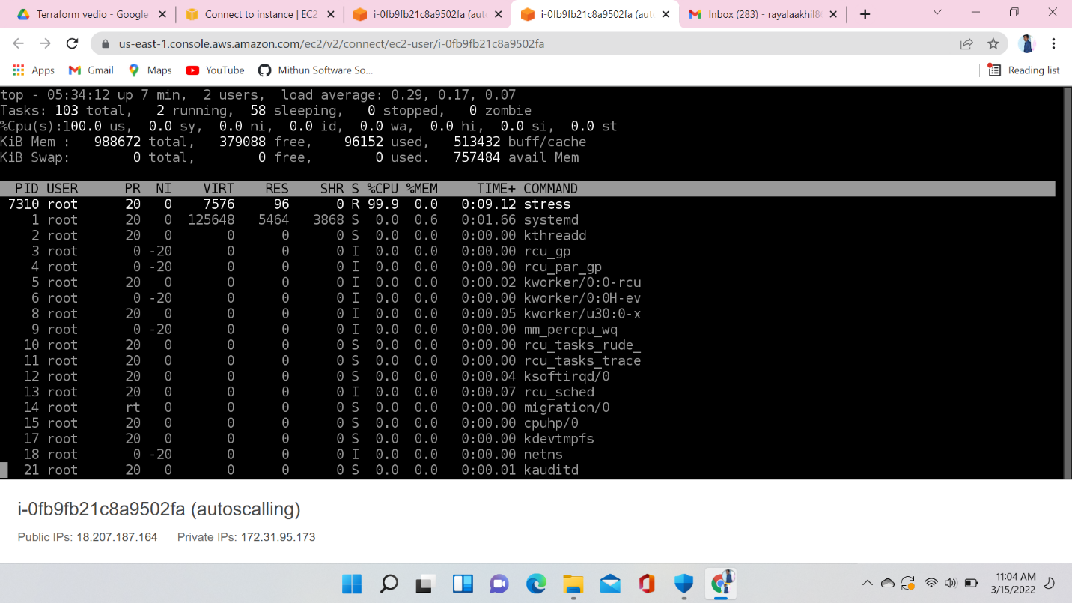

In auto scaling I said that if CPU utilization more than 50 % manage the instance. Now CPU utilization reached 99.9 … so new instance was created. If CPU utilization decreased it will automatically delete the instance

